**BUILDING E COMMERCE SYSTEM**

Building an e-commerce system involves several key steps, from planning your business model and target audience to developing and launching your online store. This includes choosing a platform, designing your website, integrating payment gateways, managing inventory, and implementing marketing strategies.

**E-commerce Website**

An **E-commerce Website** is an online platform where people can buy and sell goods and services using the Internet.  
It works like a digital shop where customers can:

* View products
* Select and order
* Make payments online
* Get the product delivered

🛒 **Examples:**

* **Daraz.com.np** — Online shopping in Nepal
* **Amazon.com** — Global e-commerce site
* **Flipkart.com** — India-based online marketplace

**Purpose:**

* Selling products/services directly to customers
* Reducing physical shop costs
* Reaching more customers anytime

**2️⃣ E-commerce Software**

E-commerce Software is the tool or system that helps in building and running the e-commerce website.  
It manages:

* Product listings (adding, editing products)
* Shopping cart and checkout process
* Online payment gateway integration
* Order and inventory management
* Customer records and reports

🛠️ **Examples of E-commerce Software:**

* **Shopify** — Used by businesses to set up online stores
* **WooCommerce** — A plugin for WordPress websites
* **Magento** — Popular for large-scale e-commerce stores
* **OpenCart** — Open-source software for online stores

**3️⃣ Why We Use E-commerce Website and Software in E-commerce?**

| **Purpose** | **How It Helps** |
| --- | --- |
| **Online Selling** | Allows customers to shop easily via website |
| **Order Management** | Tracks and manages orders and delivery |
| **Payment Handling** | Secure online payment system integration |
| **Inventory Management** | Keeps track of available stock and updates automatically |
| **Customer Management** | Saves customer info, order history, and contact details |
| **Marketing & Promotion** | Helps with discounts, ads, offers, SEO tools |
| **24/7 Business** | Store is always open online, not limited by time or place |

### A Better E-commerce Website Must Have the Following Things:

| **Required Features** | **Why It Is Important** |
| --- | --- |
| **User-Friendly Design** | **Easy navigation, clear layout, attractive look** |
| **Mobile Responsive** | **Works smoothly on mobiles and tablets** |
| **Fast Loading Speed** | **Customers won’t wait for slow websites** |
| **Secure Payment System** | **Safe online payments (SSL, HTTPS)** |
| **Product Search & Filter** | **Easy to find products with search and categories** |
| **Detailed Product Info** | **Clear description, price, images, reviews** |
| **Shopping Cart & Checkout** | **Simple add-to-cart and smooth checkout process** |
| **Customer Support** | **Live chat, FAQs, contact details** |
| **Order Tracking System** | **So customers can track their orders** |
| **SEO & Marketing Tools** | **Helps website rank on search engines** |
| **Review & Ratings System** | **Builds trust with other customer feedback** |
| **Return/Refund Policy** | **Clear policy makes customers feel secure** |

**EXAMPLE:**

* **Amazon** uses all of these:
  + Clean design, fast checkout, trusted payments, and customer support
  + Mobile app & website both responsive

A better e-commerce website must be **easy to use, fast, secure, and reliable**, with all the necessary features to help customers buy comfortably and make the business grow.

**Building Catalog in E-commerce:**

**Building a catalog** means creating a detailed and organized list of products or services you are offering in your online store.

**Building a catalog** means preparing a complete product list with details, photos, and prices, so customers can easily view and buy products online.

It includes:

* Product Names
* Descriptions
* Prices
* Categories
* Images
* Stock availability
* Product specifications (size, color, brand, etc.)

**📦 Example in Online Store:**

| **Product** | **Description** | **Price** | **Stock** | **Image** |
| --- | --- | --- | --- | --- |
| iPhone 14 | 128GB, Black | $999 | In Stock | 📷 |

**🎯 Why Building a Catalog is Important:**

* Helps customers easily find and compare products
* Provides complete product information
* Makes inventory and order management easier
* Increases sales through better presentation

**Catalog and Its Types in E-commerce**

* **Catalog** means a detailed list of products or services offered by a business.
* It includes product name, price, description, images, and stock details.
* Catalog helps customers view, compare, and choose products easily.

**🔹 Types of Catalogs:**

1️⃣ **Printed Catalog** — Physical booklets (e.g., brochures)  
2️⃣ **Online/Digital Catalog** — Shown on websites and apps (e.g., Daraz, Amazon)  
3️⃣ **PDF Catalog** — Downloadable product list in PDF format  
4️⃣ **Interactive Catalog** — Clickable catalogs with videos or animations  
5️⃣ **E-commerce Platform Catalog** — Managed by software like Shopify, Magento

### ****Static and Dynamic Catalog****

### 

* **Static Catalog**  
  A fixed product list that does not change automatically.  
  It needs to be updated manually.  
  Example: Printed catalog, PDF brochure.
* **Dynamic Catalog**  
  A live product list that updates automatically from the database.  
  It changes when products, prices, or stock change.  
  Example: Online shopping websites like Amazon, Daraz.

### ****Building a Shopping Cart in E-Commerce****

### 

A **shopping cart** is a critical component of any e-commerce website. It allows customers to select products, review their selections, make modifications, and proceed to checkout.

### ****Basic Procedure to Build a Shopping Cart****

#### 1️⃣ **Requirement Analysis**

* Define purpose: Will it support single or multiple products?
* Will it require user registration or guest checkout?
* Payment gateway support (e.g., PayPal, eSewa, Khalti)
* Security and data handling

#### 2️⃣ **Design the Database Structure**

* **Products Table** (ProductID, Name, Description, Price, Stock)
* **Users Table** (UserID, Name, Email, Password)
* **Cart Table** (CartID, UserID, CreatedDate)
* **CartItems Table** (CartItemID, CartID, ProductID, Quantity)

#### 3️⃣ **Front-End Development**

* **Product Display Page** — List of products with "Add to Cart" button
* **Cart Page** — Shows items added, total price, quantity modification
* **Checkout Page** — Billing information, payment options

Tools:

* HTML, CSS, JavaScript, Bootstrap
* Frameworks: React.js, Vue.js, or plain JavaScript

#### 4️⃣ **Back-End Development**

* **Handle Add to Cart** — Store item with quantity in session/database
* **Update Cart Items** — Allow user to change quantity/remove items
* **Checkout Handling** — Calculate total, generate order summary
* **Order Processing** — Connect with payment gateway and confirm order

Languages/Frameworks commonly used:

* PHP, Python (Django/Flask), Node.js (Express), ASP.NET

#### 5️⃣ **Session or Database Management**

* Temporary carts are usually managed via **Sessions**
* Logged-in users' carts are saved in the **Database**

#### 6️⃣ **Integrate Payment Gateway**

* Use APIs provided by Payment Services (e.g., Stripe, PayPal, Khalti)
* Handle success/failure response after payment

#### 7️⃣ **Test Cart Functionality**

* Add/Remove Items
* Quantity changes
* Price updates
* Checkout and payment processing  
  Test across multiple browsers and devices.

#### 8️⃣ **Secure the Shopping Cart**

* Validate all inputs
* Use HTTPS
* Implement token-based CSRF protection
* Encrypt sensitive data

#### 9️⃣ **Deploy and Monitor**

* Host on a reliable server
* Monitor for bugs and user feedback
* Update and maintain regularly

### ****Simple Example Process****

1. User selects "Add to Cart" on a product.
2. Cart updates in real-time (AJAX).
3. User views cart summary and edits items.
4. Clicks "Checkout", fills billing details.
5. Makes payment via integrated gateway.
6. Order confirmation is sent.

**Transaction Processing**  
Transaction Processing refers to the way computer systems manage and execute database transactions. A **transaction** is a unit of work that is performed against a database and must be **completed fully or not at all**.

**Example of a Transaction:**

* A bank transfer of money from Account A to Account B
  + Debit Account A
  + Credit Account B
  + If any of the steps fail, the entire transaction must be rolled back.

**Characteristics of Transaction Processing (ACID Properties):**

1. **Atomicity** – All operations of the transaction are completed or none are.
2. **Consistency** – Transaction transforms the database from one valid state to another valid state.
3. **Isolation** – Concurrent transactions do not affect each other.
4. **Durability** – Once completed, the transaction’s changes are permanent.

**Types of Transaction Processing:**

* **Online Transaction Processing (OLTP):**  
  Real-time processing, used in banks, shopping sites, etc.  
  Example: ATM transactions, Online shopping cart.
* **Batch Transaction Processing:**  
  Transactions collected and processed at a scheduled time.  
  Example: Payroll processing, Utility bill generation.

**Transaction Processing System (TPS):**

A TPS is software that manages transaction data in an organization.

**Functions of TPS:**

* Data collection
* Storage
* Processing
* Output generation (reports, receipts)

**Advantages:**

* Accuracy and reliability
* Data integrity
* Quick processing
* Supports business operations

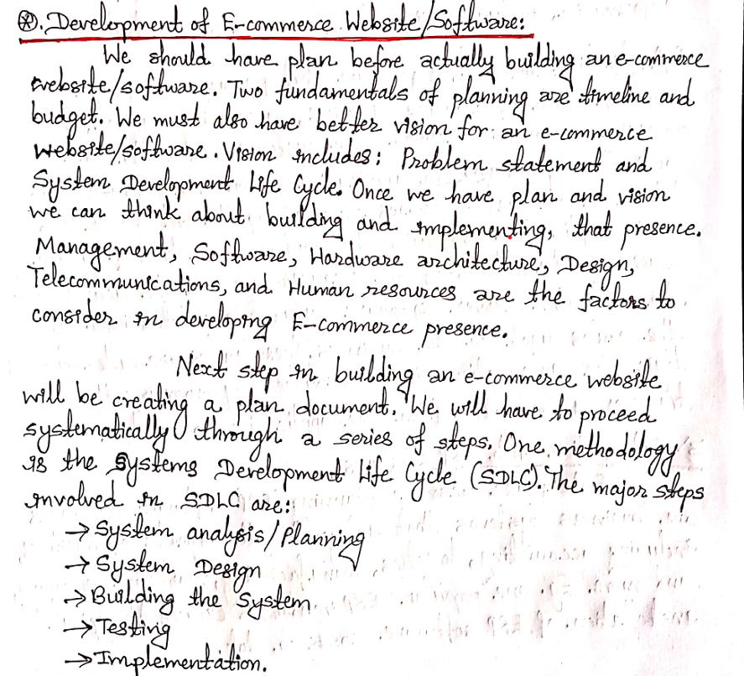

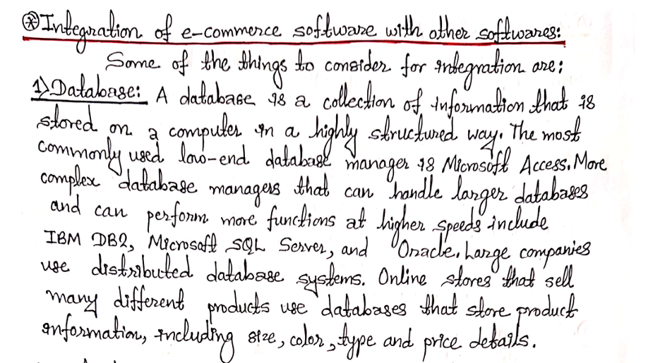

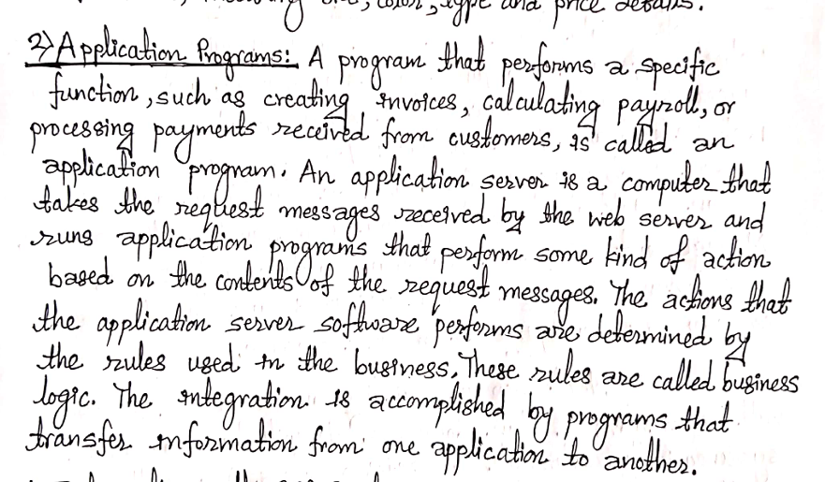

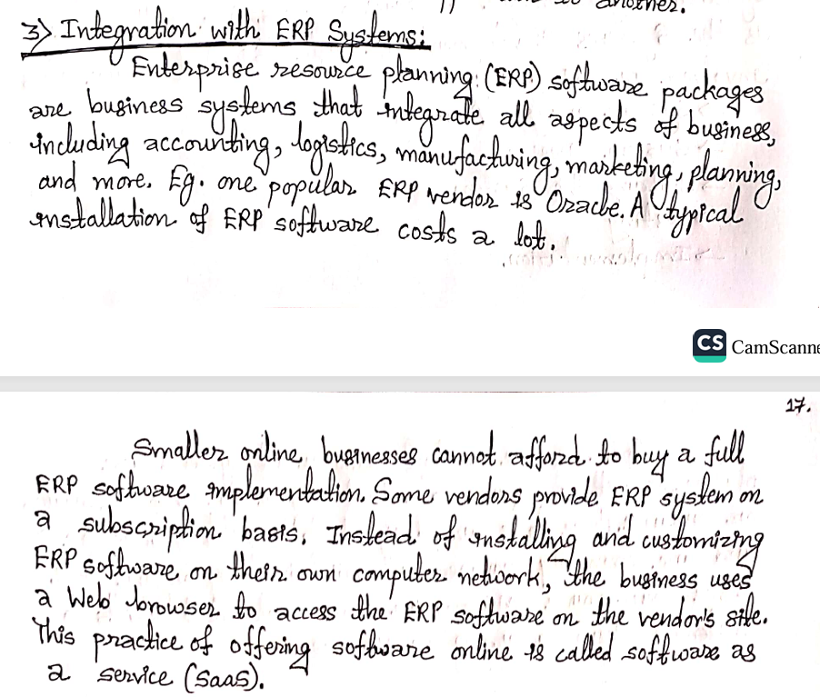

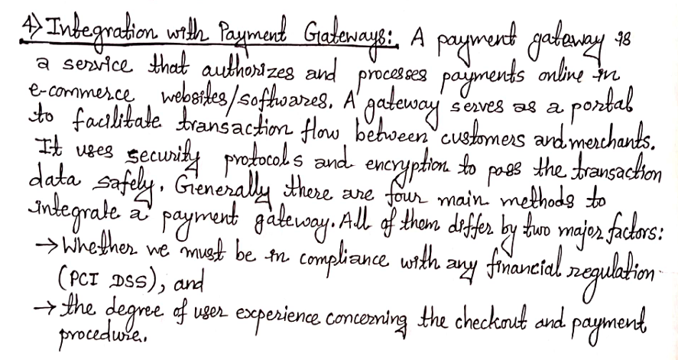

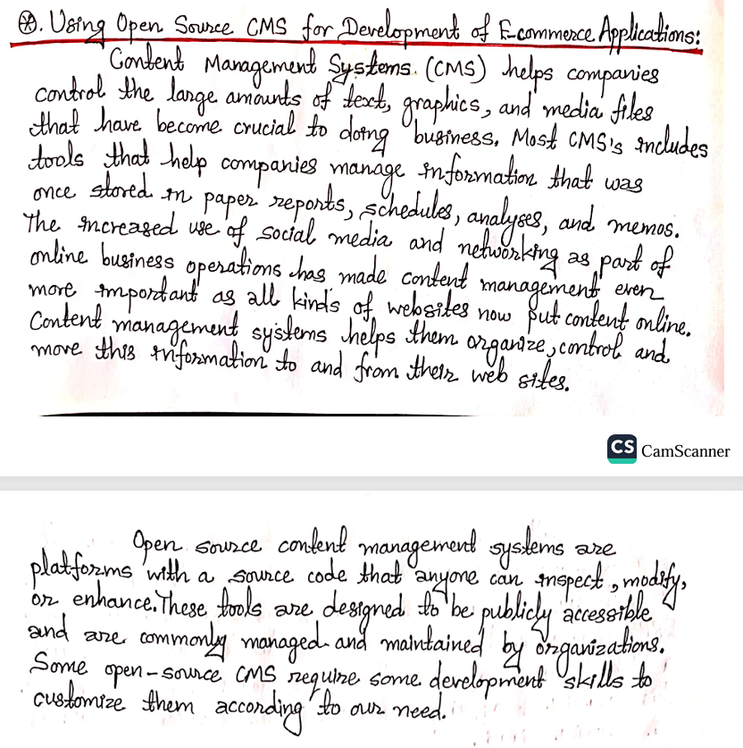

**Why we use open source cms for development ?**

= An **Open Source CMS (Content Management System)** is a software whose source code is freely available, allowing developers to modify, customize, and use it without licensing fees.

**Reasons for Using Open Source CMS:**

1. **Free to Use (Cost-effective):**  
   No license fees; reduces development costs.
2. **Customizable & Flexible:**  
   Developers can modify code, add plugins, and create custom features.
3. **Large Community Support:**  
   Thousands of developers contribute updates, plugins, and security patches.
4. **Security Updates & Regular Improvements:**  
   Frequent updates by the community to fix bugs and improve security.
5. **Easy to Use & Manage Content:**  
   User-friendly interface for adding, editing, and managing content.
6. **Wide Range of Plugins & Themes:**  
   Ready-made extensions and designs for faster development.
7. **SEO & Mobile Friendly:**  
   Most open-source CMS offer SEO tools and responsive design support.

**Popular Open Source CMS:**

* **WordPress** (Blogs, websites)
* **Joomla** (Portals, communities)
* **Drupal** (Complex websites)
* **Magento/OpenCart** (E-commerce)

**Example:**

A small business can create a professional website using **WordPress** without hiring expensive developers.

2.why we use catalog in website development/website design?

A **catalog** in website development is a structured way to display products, services, or content for users.  
It acts like an **online showcase** for visitors to browse, search, and select items.

**Main Reasons for Using a Catalog in a Website:**

1. **Organized Display of Products/Services:**
   * Helps arrange items by category, price, brand, or type.
   * Makes browsing easier for customers.
2. **Improves User Experience (UX):**
   * Clear navigation and filters allow users to find what they want quickly.
3. **Supports E-commerce Functionality:**
   * Essential for shopping websites to show product details, prices, stock status.
4. **Better Content Management:**
   * Easier for admins to add, edit, or remove products using CMS or backend tools.
5. **Increases Sales Opportunities:**
   * By showcasing full range of products, cross-selling, and upselling becomes easier.
6. **SEO Benefits:**
   * Well-structured product catalogs help search engines index pages, boosting search rankings.
7. **Responsive Design & Mobile Access:**
   * Catalogs can be designed to work on different devices for a better reach.

**Example:**

In an online clothing store —  
The **catalog** displays categories like *Men, Women, Kids*, with filters for size, color, and price.